Dear Parents/Guardians,

In order to strengthen our school to home communication and to better support your child academically, this guideline will be assisting all parents Public Policy Charter School to access our new online Parent PowerSchool Portal to create student accounts for your child (ren). This portal comes with great benefits to you and your child. It will serve as an additional tool to assist you in monitoring your child’s academic progress throughout the school year, along with receiving other important school information. Administration, teachers and support staff at PPCS will be assisting you through this new electronic notification system to provide you with access to your child’s progress from the comfort of your home.

**Below is a list of all the benefits that come with this new parent PowerSchool communication system:**

* Real Time Access 24 hours a day!
* View students grades and track academic progress in all classes
* View students attendance
* View homework/classwork and other assignments posted by teacher(s)
* View students cafeteria balance
* Receive important email notifications regarding your child’s academic progress/important school information
* If you have more than one child enrolled at PPCS, you will be able to view all your children’s information on your Parent PowerSchool Account
* Important announcements and our weekly parent reminder will be posted on a regular basis
* After creating your Parent PowerSchool Account, you can also download the *PowerSchool for Parent* App onto your iPhone or Android for easier access to view your child’s information from your cellphone. Please note: in order to download this App, you first have to create your Parent PowerSchool Account online via a computer.
* Parent PowerSchool Account is also available in Spanish!

We are very excited to implement this new parent communication portal through PowerSchool! Please feel free to ask questions, provide feedback, concerns or suggestions at any time. For parents that don’t have a computer or internet access at home, please feel free to stop by our main office to obtain a hardcopy your child’s PowerSchool information.

**Parent Guide to Parent PowerSchool Portal**

**How do I get started? – The following steps must take place in order to create your account.**

1. You must have an active email address. If you don’t have an email address, please create one. For parents that need assistance creating an email address, we encourage you to ask a friend or family member that can assist you so that you can begin this process right away. For those of you who need assistance, we will be scheduling workshops on how to create an email account during the first and second week of school.
2. 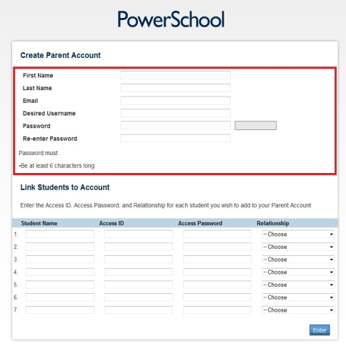Once you have an email account, you will then need to visit the following link to create your PowerSchool Parent Account. https://ppcs.pslogin.com/public/home.html
3. Once you open up the link mentioned above, you will select the

language of your choice and click on the bottom right “Create

Account”. This will take you to the screen on the right.

Fill out all the information needed to create your account.

1. Parents will need an Access ID/Password for each child attending

our school in grades 5-6.

In order to create your account and view all your child (rens)

Information, parents are able to request their child’s Access ID/

Password through the main office during office hours (8:00am –

3:00pm).

For Technical Support, please contact our PowerSchool technical support team at 323.205.7920

or email [powerschool@publicpolicycharterschools.org](mailto:powerschool@publicpolicycharterschools.org)